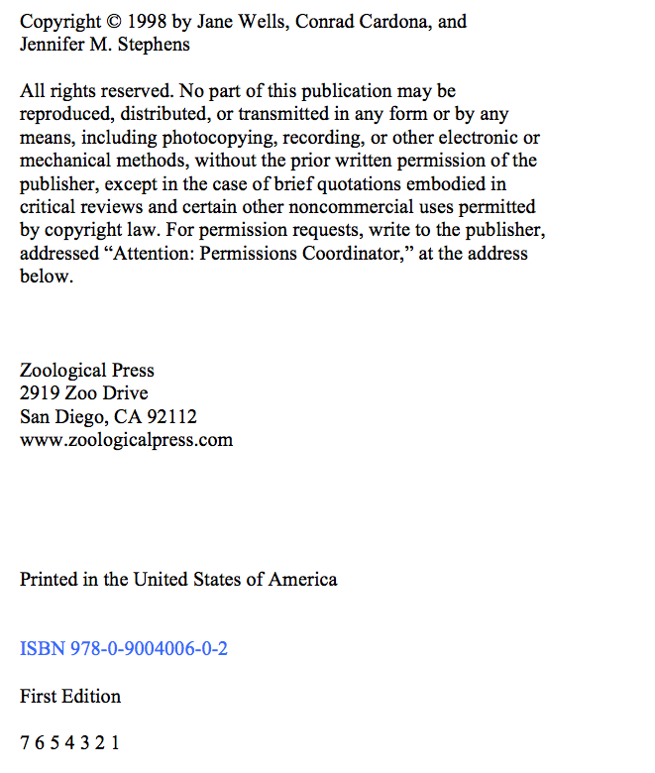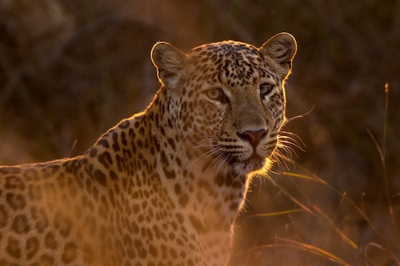

A Field Guide to

Big Cats

Jane Wells,

Conrad Cardona,

Jennifer M. Stephens

Zoological Press